Errata for Math Mammoth Grade 6, 2022 edition
Grade 6-A Worktext
Unit Rates
Teaching box at the top.
Was: "but the "per kilogram" means "per one pound"."
Should be: but the "per kilogram" means "per one kilogram".
Was: 2/5 tsp per dl.
Should be: 2/5 tbsp per dl.
(Error noted Dec 15, 2022)
Using Equivalent Rates
#9. The labeling for the axes (j and t) in the coordinate grids in the problem itself and in the answer key is not matching. The image for the student worktext needs the j and t axes switched. The corrected image is below:
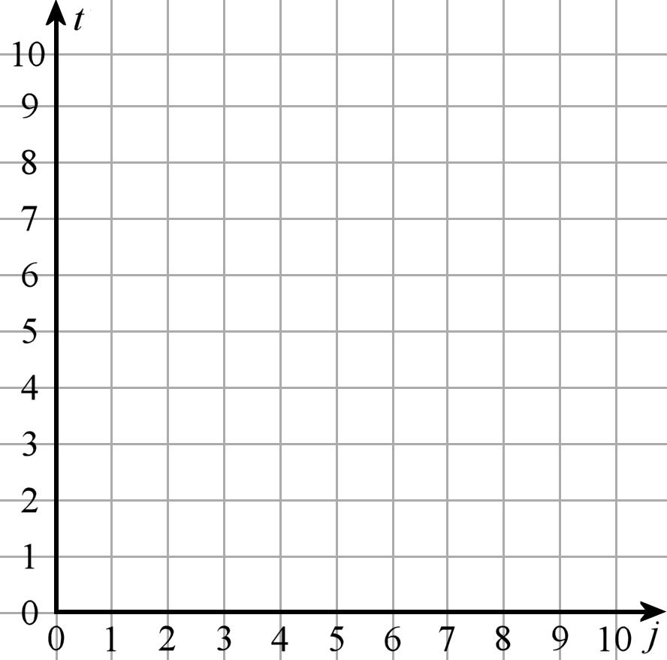
Grade 6-A Answer Key
Chapter 1
Warm-Up: Mental Math (p. 14 in the student book)
#10 a. The ingredients cinnamon and nutmeg were reversed from what they are in the workbook.
(Error noted Aug 16, 2023)
Review of the Four Operations 2 (p. 17 in the student book)
#7a. In the table, when "Time" is 2 ½ hours, "Miles" should be 135, not 125.
(Error noted Aug 6, 2022)
Chapter 2
Using Two Variables (p. 88 in the student book)
#4. The graph shown was for the metric version of this exercise, where the speed is 80 km/h. The correct graph is this:
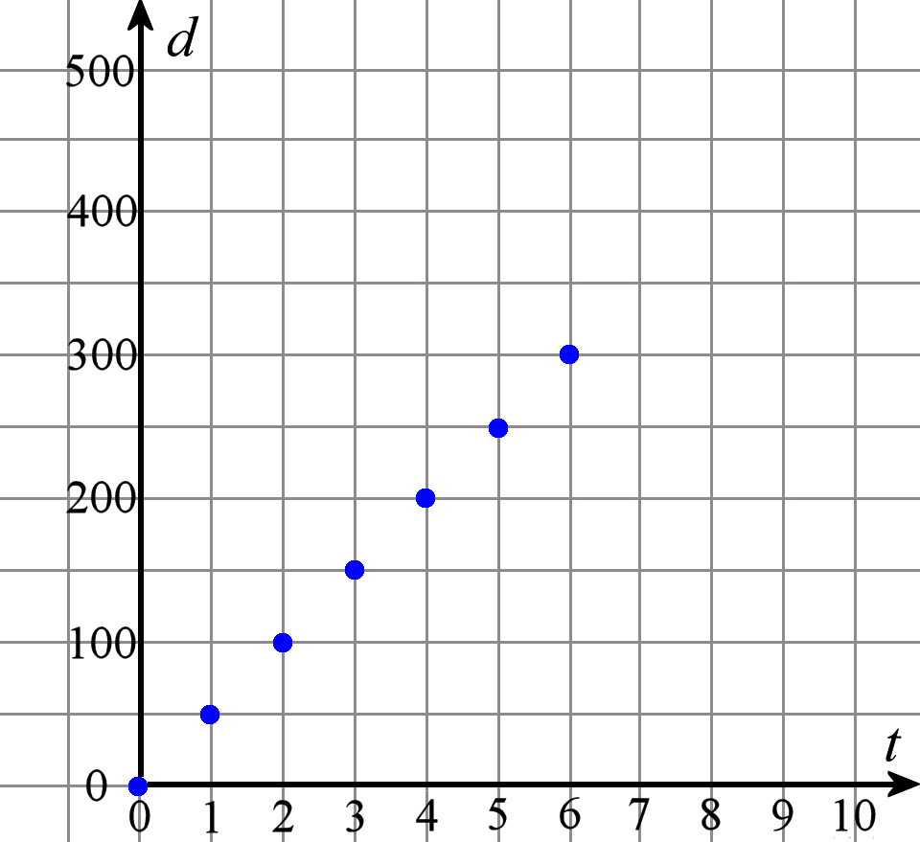
Also, "kilometers" needs changed to "miles" in the table.
(Error noted Dec 6, 2023)
Chapter 4
Unit Rates (p. 150 in the student book)
#6 Was: “In eight hours, the airplane can travel 8 · 5,000 km = 40,000 m.”
Should be: “In eight hours, the airplane can travel 8 · 500 mi = 4,000 mi.”
(Error noted Jul 25, 2023)

Chapter 4 Review (p. 170 in the student book)
#10 The answer was not matching the question. The answer was about squares and their areas. The correct answer is below.
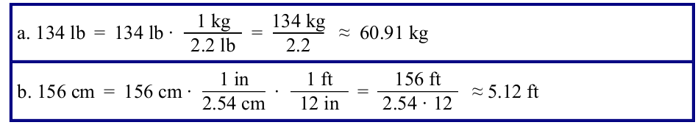
(Error noted Dec 9, 2022)
Grade 6-B Worktext
Chapter 6
Factoring Sums, p. 23
Question #2 is in centimeters and #3 is in meters. Questions #2 and #3 should use the same unit for consistency, since question #4 references both. Question #2 should be in meters, therefore, not in centimeters.
(Error noted March 16, 2024)
Chapter 7
Review: Multiplying Fractions 2, p. 48
The teaching box on page 48 (just before #5) shows 5 · 5 = 15 which is in error, and then leads to the wrong answer for the entire calculation.
Here is the correct way:
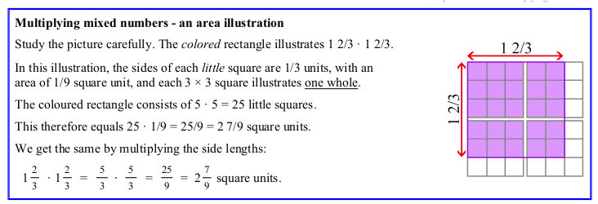
(Error noted... unfortunately we’re not sure on the date on this one. )
Chapter 8
Mixed Review Chapter 8
Question #4 says to give answer in kilograms. It should say pounds and ounces.
(Error noted Dec 15, 2022)
Chapter 9
Geometry Review
#5 a. should say inches instead of cm.
(Error noted March 28, 2024)
6-B Answer Key
Chapter 6
Factoring Sums
#2 should be in meters, not centimeters, for consistency, since #3 also uses meters and #4 (in the worktext) references both #2 and #3.
#5 Similarly should be in meters, for consistency, and not in centimeters. Also, the possibility of using a 10-m (10-cm) side was not included. Here is the updated answer:
5. The sides of 1 m, 2 m, 5 m, and 10 m can all be used for the answer in problem 4. So, the rectangles that are side-by-side can be 30 m × 1 m and 40 m × 1 m, OR 15 m × 2 m and 20 m × 2 m, OR 6 m × 5 m and 8 m × 5 m, OR 3 m × 10 m and 4 m × 10 m.
(Error noted March 16, 2024)
Tests Answer Key
Chapter 4 Test
#8 The answer was using metric units (it was the answer for the international version of this question.) Here is the correct answer.
8. a. 35 gal per 7 mi = 5 gal per mile.
b. The plane can fly 500 gal/ (5 gal/mil) = 100 miles with 500 gallons of fuel.
c. The plane will need 150 mi · 5 gal/mi = 750 gallons of fuel to travel 150 miles.
End-of-Year Test
#30 b is missing its answer, and the answer for (c) is labeled as (b). It should be:
b. 0.412 mi = 2175.36 ft
c. 1.267 lb = 20.27 oz

#53c should be: 4 ÷ (5/5) = 4 · (7/5) = 28/5 = 5 3/5

Additionally, the answer for (d) should be removed as there is no (d) in this question.

#54 has a wrong picture. The pie image for 2/3 should be 3/5 instead so that the mixed number shown is 3 3/5. This is the corrected version:
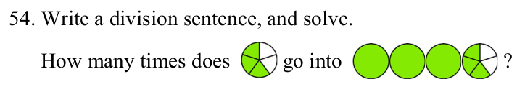

#57 and 58. This was correct in2022, but somehow the wrong questions have crept back in to the U.S. version in 2023. Question 57 should read as below, and question 58 should be eliminated.

57. A rectangular room measures 3 ¾ meters by 5 meters. It is divided into three equal parts.
Calculate the area of one of those parts.

# 71/72. The question uses centimeters. It should just use units, and read:
“The edges of each little cube measure 1/2 unit.”

#72/73. This question had been changed to an easier problem in the past but somehow the more difficult one crept back in during 2023. This is the intended question:

72. A box containing a construction toy measures 4.4 cm by 21.6 cm by 15 cm.
a. Calculate the volume of the box, to the nearest ten cubic centimeters.
b. Calculate its surface area, to the nearest ten square centimeters.

73/74 has a wrong question. This is the intended question:

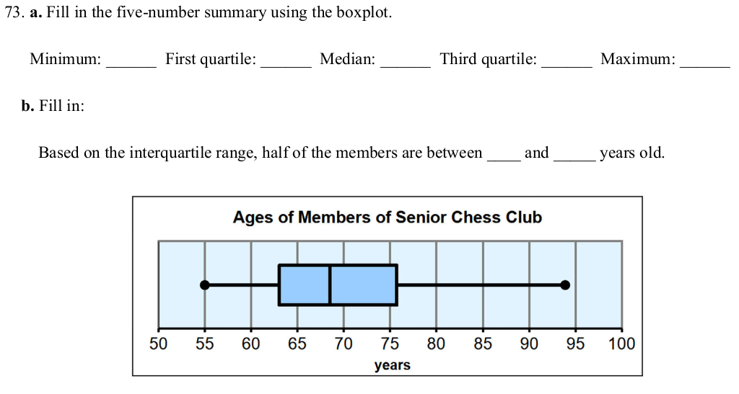

75/76 The question asking to describe the spread of the data should be removed.
(Errors for the EOY test noted May 24, 2024)

