Errata for Math Mammoth Grade 3, 2024 edition
Grade 3-A Answer Key
Chapter 1
Mental Math with Three-Digit Numbers (student worktext p. 30)
#4. a. The answers should be 259, 89, 239 instead of 269, 89, 249.
(Error noted Jul 29, 2024)
A Letter for the Unknown 1 (student worktext p. 32)
#2. a. The answer partially uses 65 instead of 56. The answer should be:
41 + x = 56 or x + 41 = 56 or x = 56 − 41 or 56 − 41 = x. Solution: x = 15. Ann needs 15 more pins.
(Error noted Aug 15, 2024)
The Connection with Addition and Subtraction (student worktext p. 35)
#4. a. The answer uses 660 instead of 650. The answer should be:
560 + x = 650 or x + 560 = 650; x = 90
(Error noted Aug 15, 2024)
Review Chapter 1 (student worktext p. 41)
The answers for 6, 7, 8, and 9 were not matching the worktext. The correct answers are:
6. a. 3, 5
b. 3, 4
c. 8, 7
7. Student equations will vary; check the student's equations. For example:
a. N = 21 + 17 – 5. N = 33. The squirrel has 33 nuts now.
b. 15 + 5 + M = 28. M = 8. He still needs $8.
8. The numbers in the list are skip-counting by 7. When you add 7 repeatedly, every other number is
even and every other number is odd. Since 32, the last number in the list, is even, the next number will
be odd.

9. a. 6
b. 7
c. 6
(Error noted Aug 5, 2024)
Chapter 4
Multiplication Table of 4
#9b. The final answer for the number of legs was wrong. The corrected answer is:
b. 3 × 4 + 7 × 2 = 26. They have 26 legs in total.
(Error noted Oct 24, 2024)
Grade 3-B Answer Key
Chapter 9
Milliliters and Liters
#5c. The answer given is 1,200 ml. Should be 120 ml.
(Error noted May 7, 2025)
#5c also... the image is erroneous, in the fact that the scaling does not start at the bottom of the beaker.
The correct image is below.
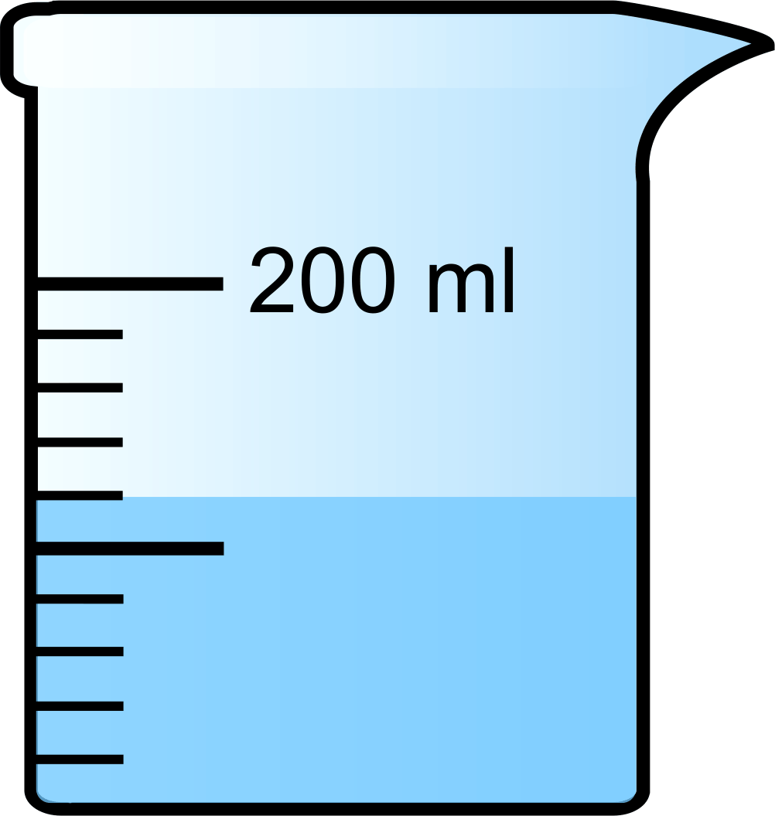
(Error noted May 12, 2025)

Cumulative Reviews Answer Key
Cumulative Review, Chapters 1-4
#4b. The answer was given as: 6 + 7 × (4 – 2) = 26
The answer should be 6 + 7 × (4 – 2) = 20
(Error noted Dec 12, 2024)

